SCHOOL OF COMPUTER SCIENCE AND ARTIFICIAL INTELLIGENCE |  |  |  |  | DEPARTMENT OF COMPUTER SCIENCE ENGINEERING
Program Name: B. Tech |  |  |  | Assignment Type: Lab |  |  | Academic Year:2025-2026
Course Coordinator Name |  |  |  | Venkataramana Veeramsetty
Instructor(s) Name |  |  |  | Dr. V. Venkataramana (Co-ordinator)  Dr. T. Sampath Kumar  Dr. Pramoda Patro  Dr. Brij Kishor Tiwari  Dr.J.Ravichander  Dr. Mohammand Ali Shaik  Dr. Anirodh Kumar  Mr. S.Naresh Kumar  Dr. RAJESH VELPULA  Mr. Kundhan Kumar  Ms. Ch.Rajitha  Mr. M Prakash  Mr. B.Raju  Intern 1 (Dharma teja)  Intern 2 (Sai Prasad)  Intern 3 (Sowmya)  NS_2 ( Mounika)
Course Code |  |  | 24CS002PC215 | Course Title |  | AI Assisted Coding
Year/Sem |  |  | II/I | Regulation |  | R24
Date and Day  of Assignment |  |  | Week6 - Thursday | Time(s)
Duration |  |  | 2 Hours | Applicable to  Batches
AssignmentNumber:11.1(Present assignment number)/24(Total number of assignments)
 | Q.No. | Question |  |  |  |  |  | Expected Time  to complete
 | 1 | Lab 11 – Data Structures with AI: Implementing Fundamental Structures  Lab Objectives  - Use AI to assist in designing and implementing fundamental data structures in Python.  - Learn how to prompt AI for structure creation, optimization, and documentation.  - Improve understanding of Lists, Stacks, Queues, Linked Lists, Trees, Graphs, and Hash Tables.  - Enhance code quality with AI-generated comments and performance suggestions.  Task 1: Implementing a Stack (LIFO)  - Task: Use AI to help implement a Stack class in Python with the following operations: push(), pop(), peek(), and is_empty().  - Instructions:  - Ask AI to generate code skeleton with docstrings.  - Test stack operations using sample data.  - Request AI to suggest optimizations or alternative implementations (e.g., using collections.deque).  Expected Output:  A working Stack class with proper methods, Google-style docstrings, and inline comments for tricky parts  PROMPT: generate a python code for implement the stacks with operations like push(), pop(),peek() and is_empty()  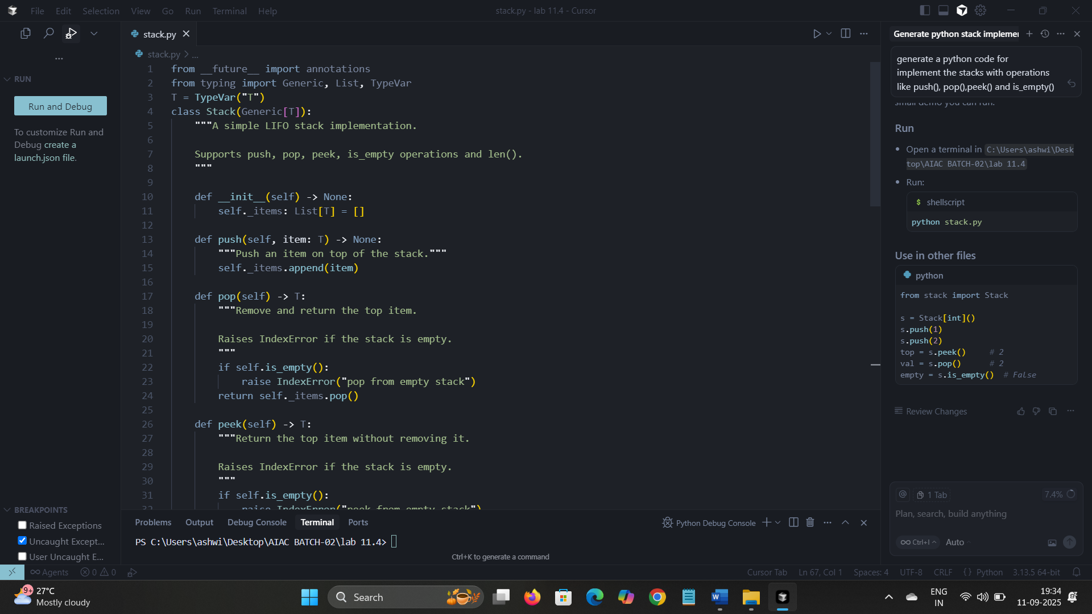  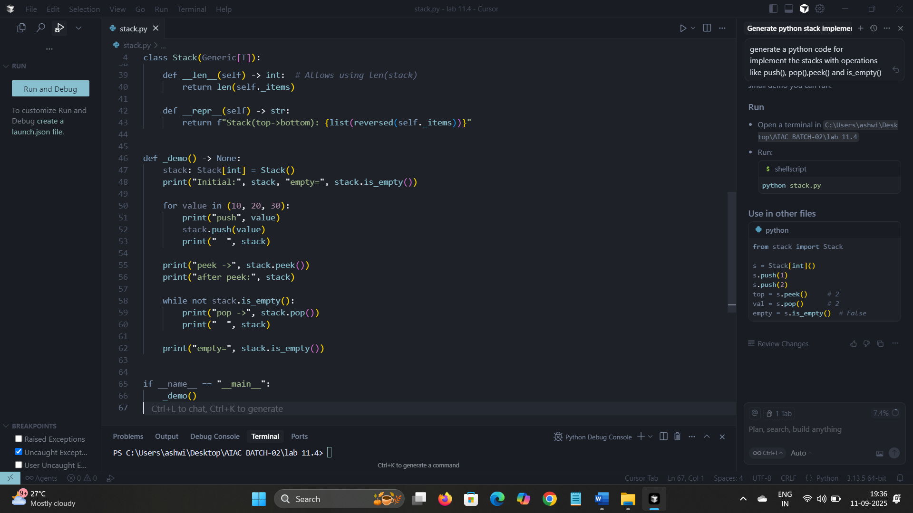  OUTPUT:  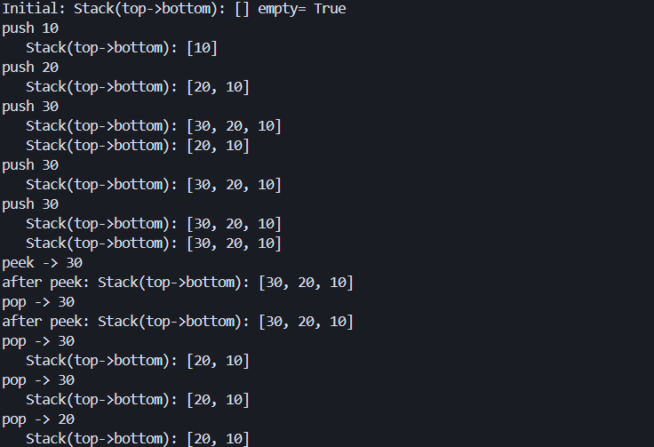  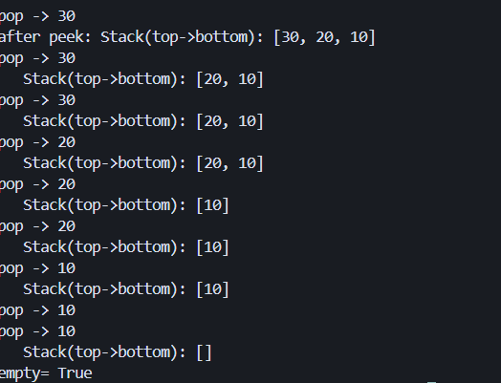  Task 2: Queue Implementation with Performance Review  - Task: Implement a Queue with enqueue(), dequeue(), and is_empty() methods.  - Instructions:  - First, implement using Python lists.  - Then, ask AI to review performance and suggest a more efficient implementation (using collections.deque).  - Expected Output:  Two versions of a queue: one with lists and one optimized with deque, plus an AI-generated performance comparison  PROMPT: generate a python code for queue with enqueu(), dequeue(), and is_empty().  . 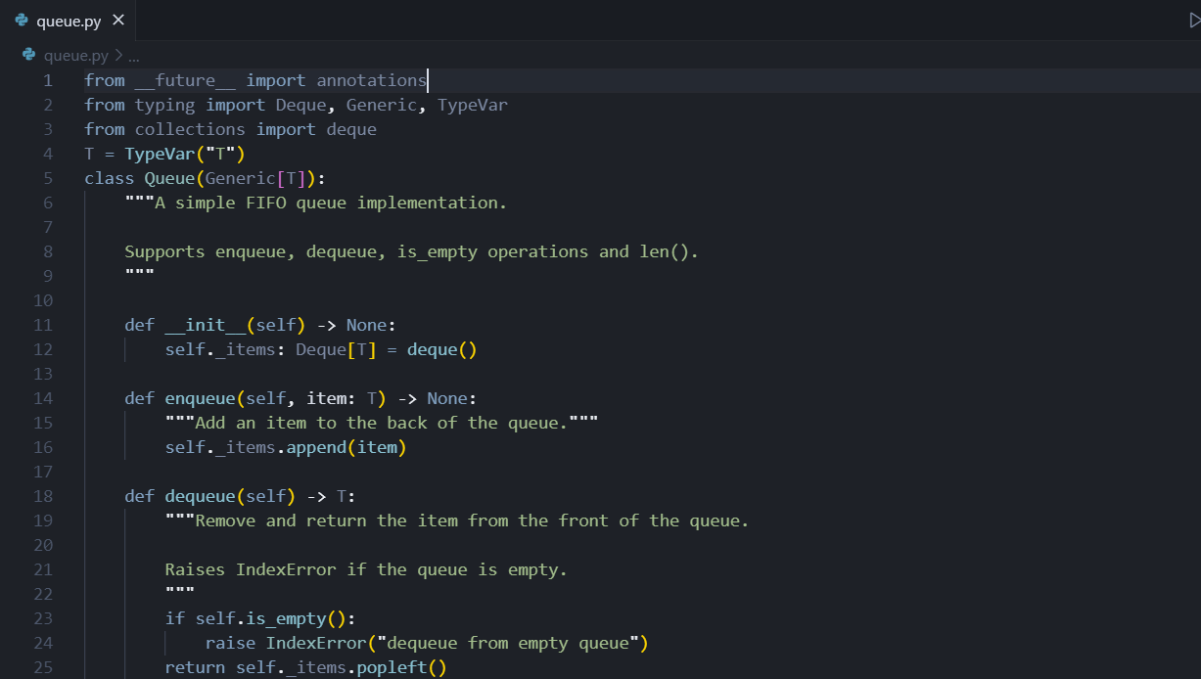  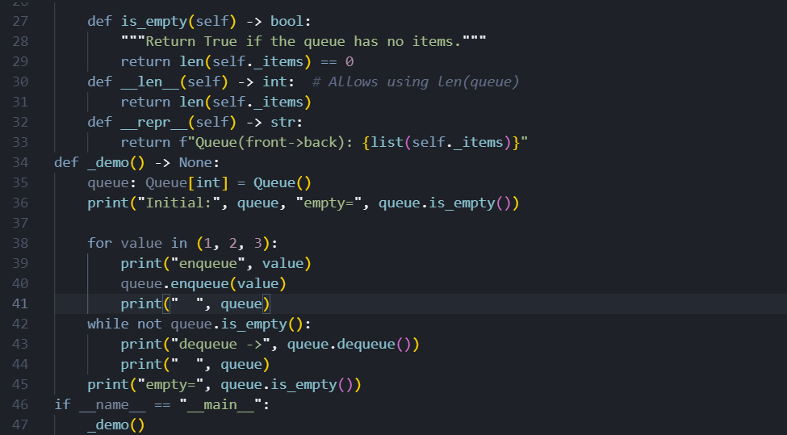  OUTPUT:  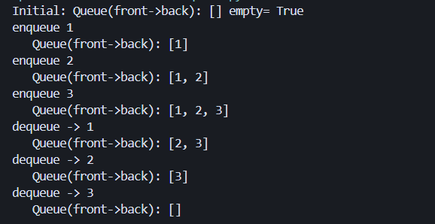  Task 3: Singly Linked List with Traversal  - Task: Implement a Singly Linked List with operations: insert_at_end(), delete_value(), and traverse().  - Instructions:  - Start with a simple class-based implementation (Node, LinkedList).  - Use AI to generate inline comments explaining pointer updates (which are non-trivial).  - Ask AI to suggest test cases to validate all operations.  - Expected Output:  A functional linked list implementation with clear comments explaining the logic of insertions and deletions.  PROMPT: generate a python code for singly linked list with operations insert_at_end(), delete_value(), and traverse()  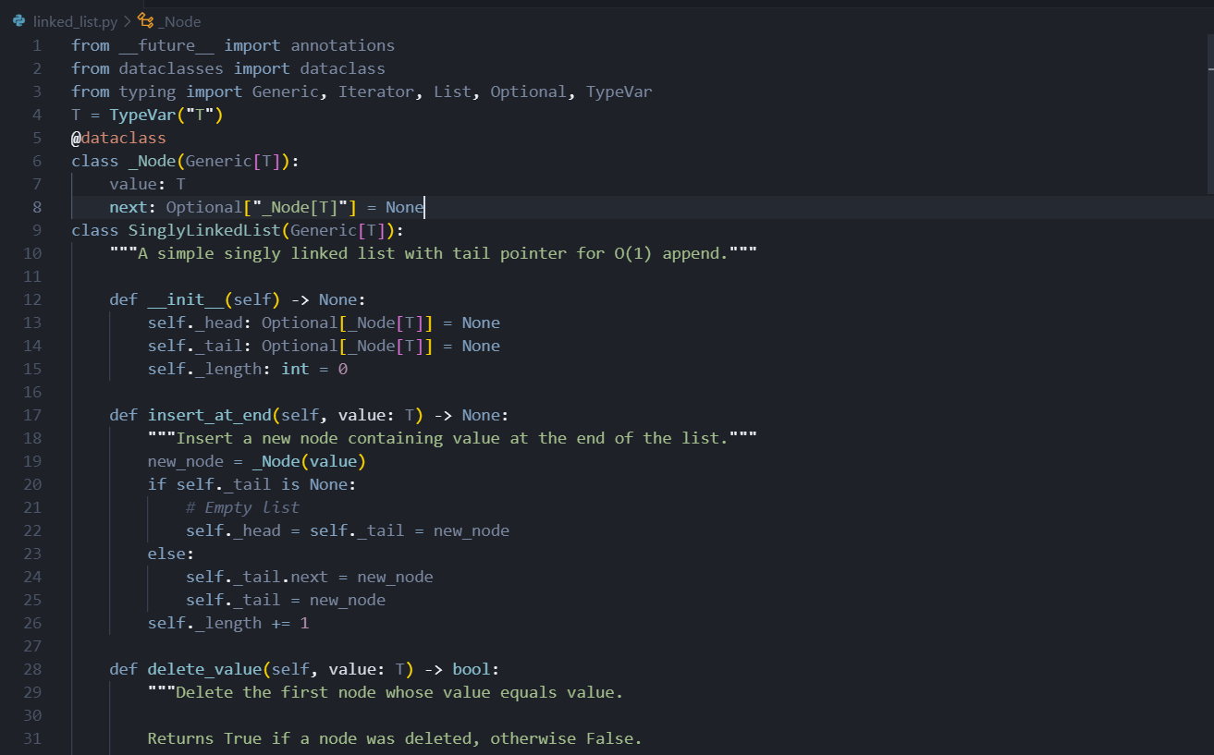  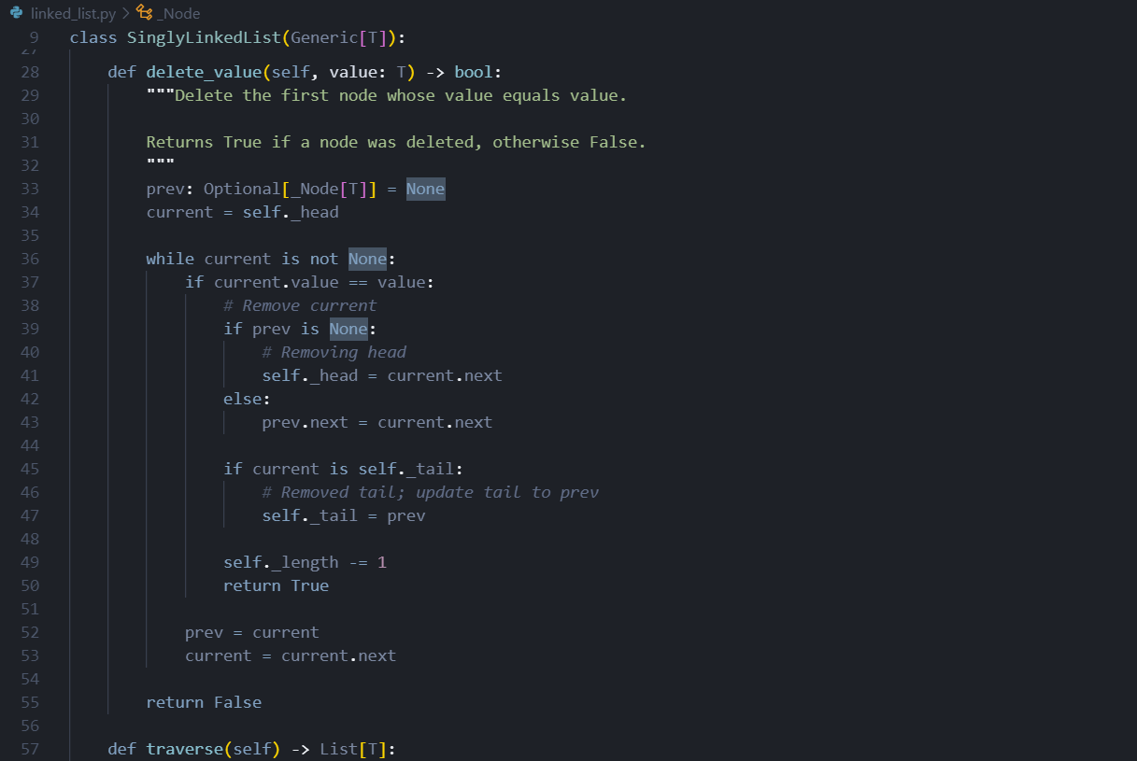  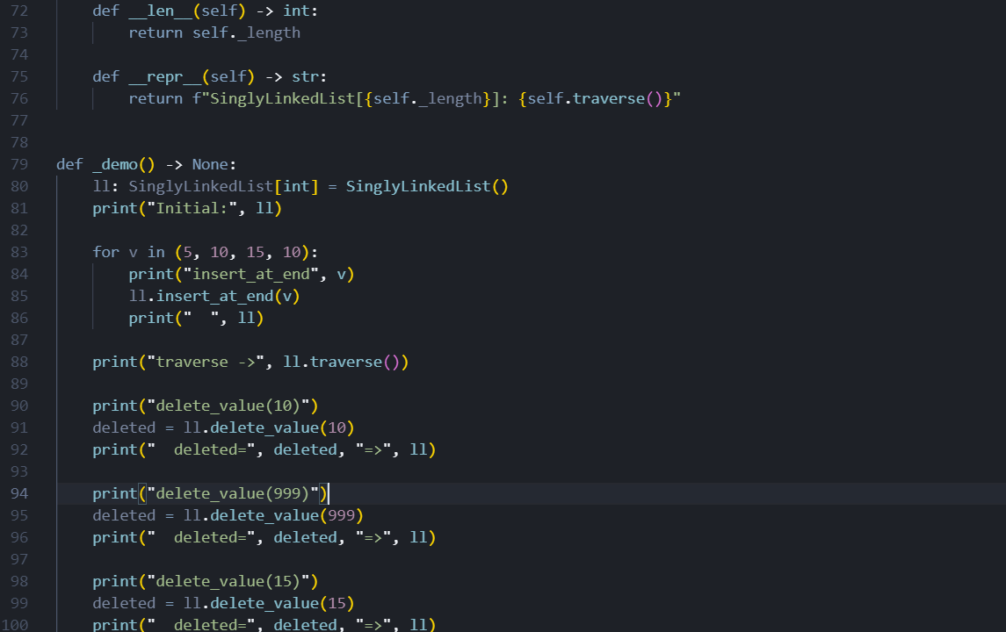  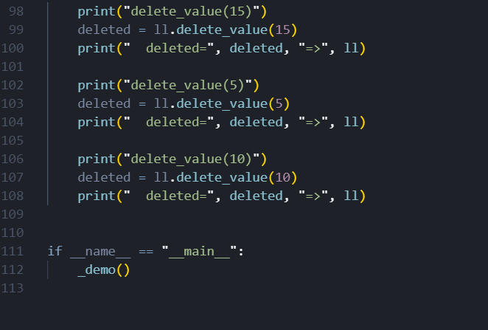  OUTPUT:  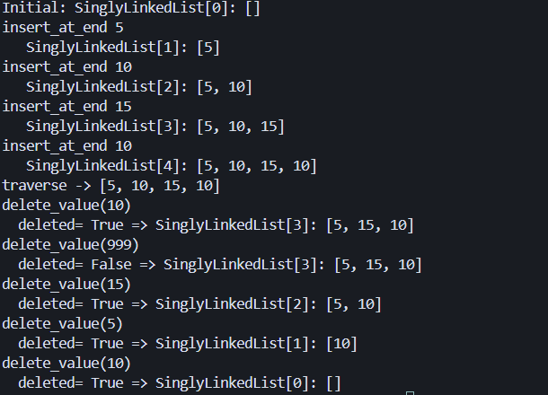  Task 4: Binary Search Tree (BST)  - Task: Implement a Binary Search Tree with methods for insert(), search(), and inorder_traversal().  - Instructions:  - Provide AI with a partially written Node and BST class.  - Ask AI to complete missing methods and add docstrings.  - Test with a list of integers and compare outputs of search() for present vs absent elements.  - Expected Output:  A BST class with clean implementation, meaningful docstrings, and correct traversal output.  PROMPT: generate a python code for binary search tree using commands like insert(), search(), inorder_traversal()  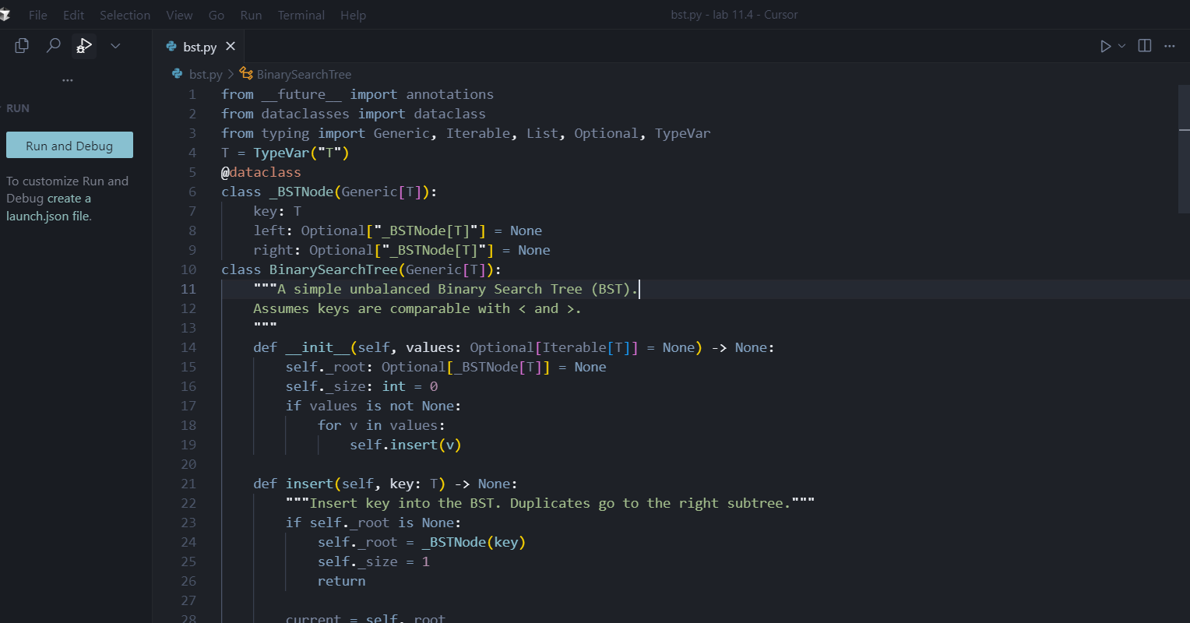  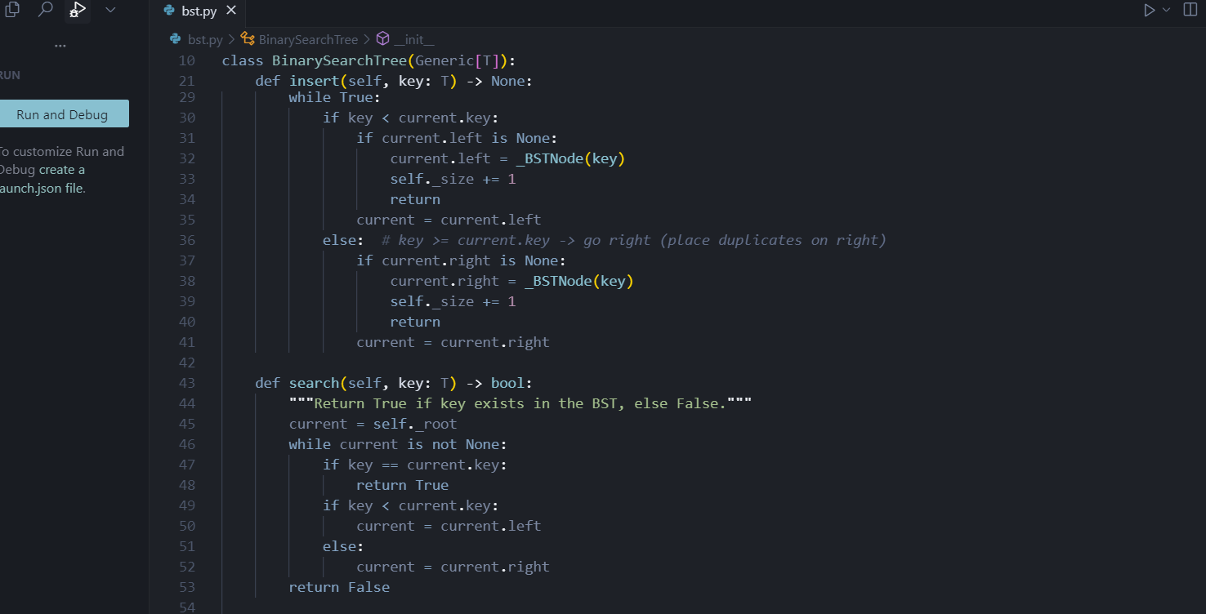  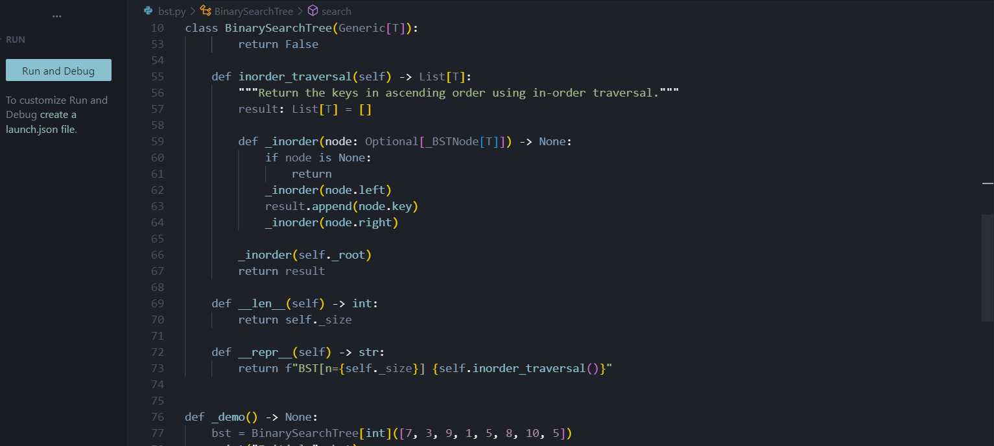  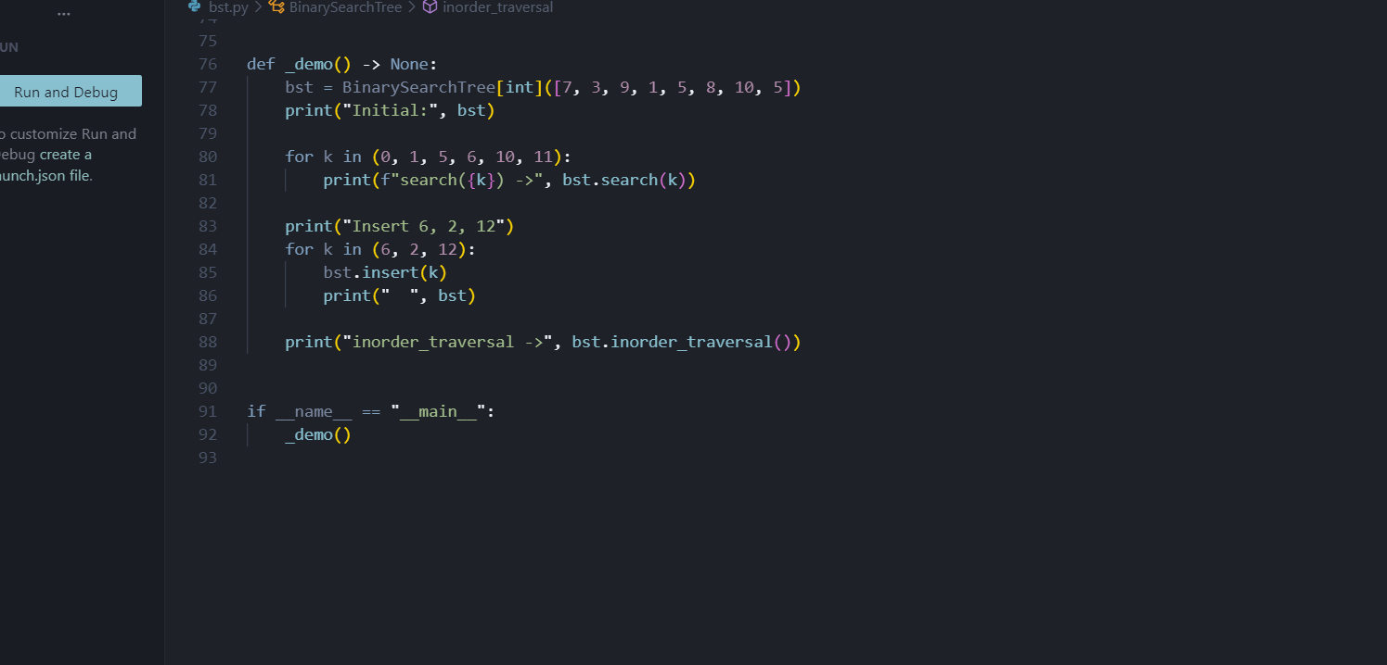  OUTPUT:  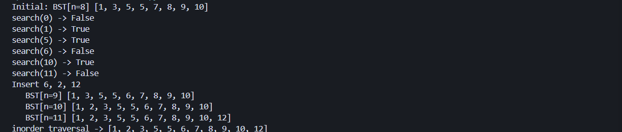  Task 5: Graph Representation and BFS/DFS Traversal  - Task: Implement a Graph using an adjacency list, with traversal methods BFS() and DFS().  - Instructions:  - Start with an adjacency list dictionary.  - Ask AI to generate BFS and DFS implementations with inline comments.  - Compare recursive vs iterative DFS if suggested by AI.  - Expected Output:  A graph implementation with BFS and DFS traversal methods, with AI-generated comments explaining traversal steps.  PROMPT:genrate a python code for graph using commands like adjacency list with traversal methods BFS() and DFS()  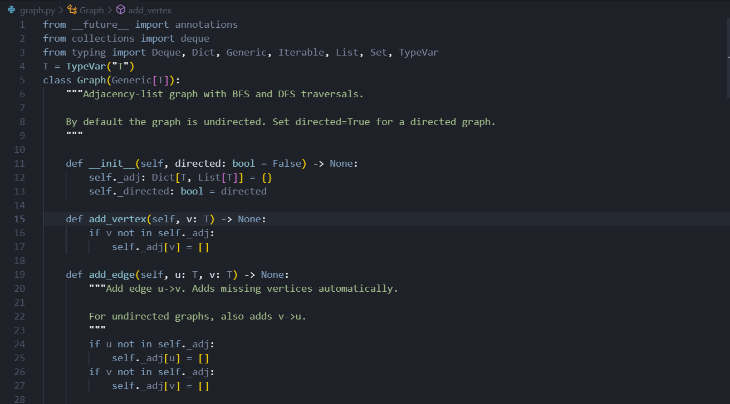  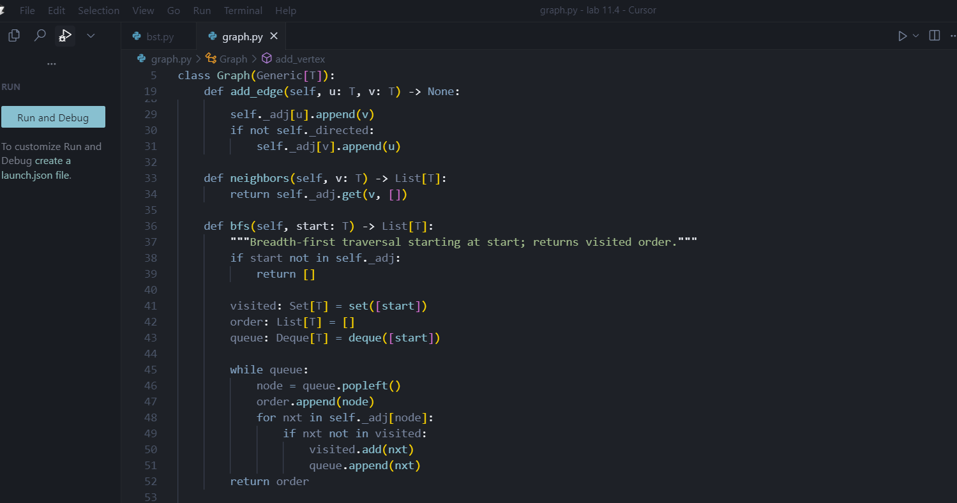  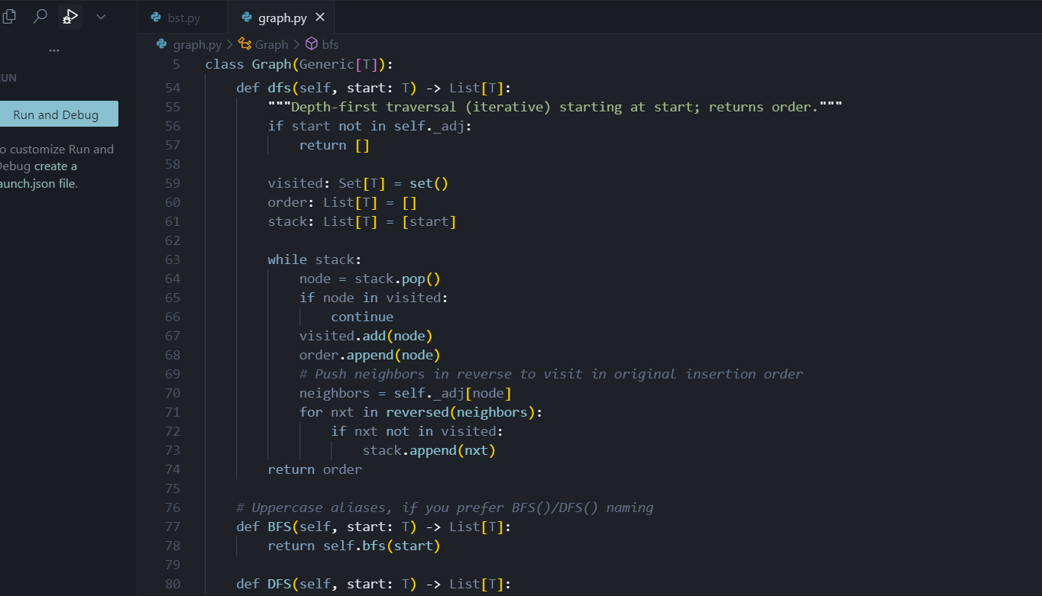  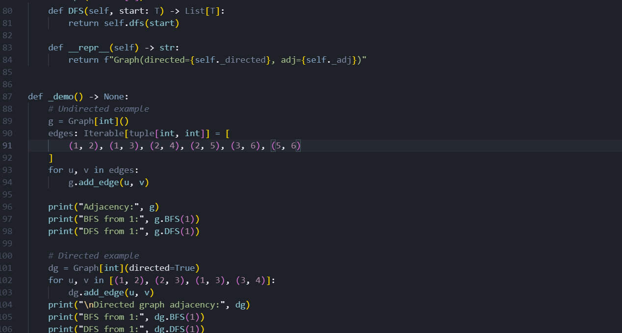  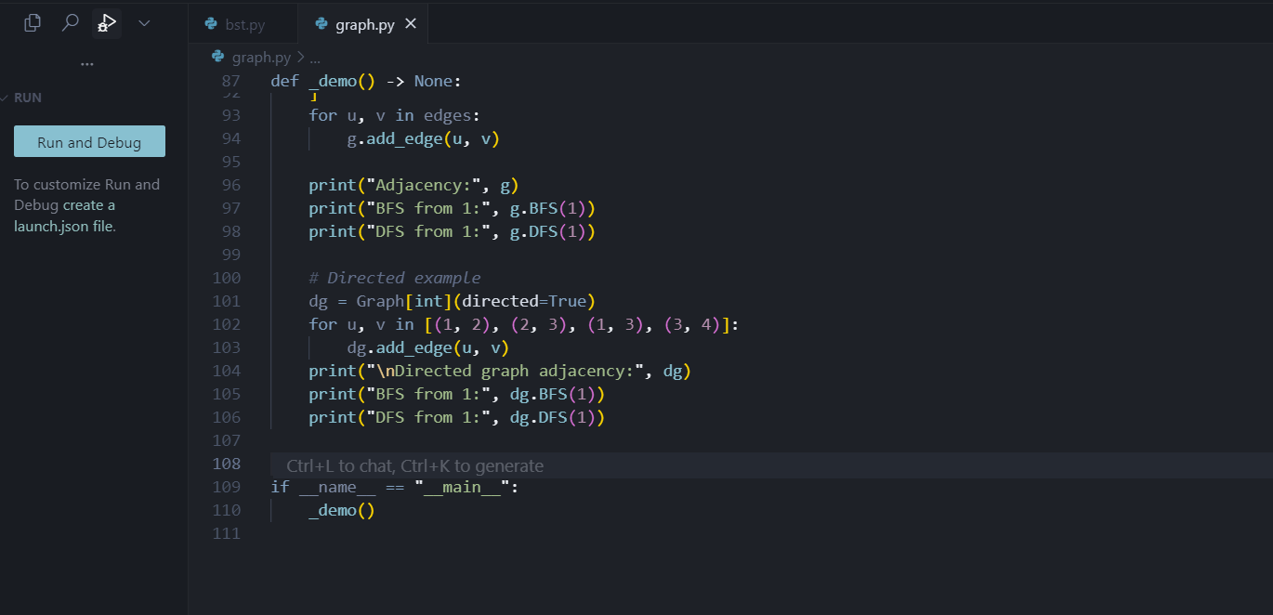  OUTPUT:  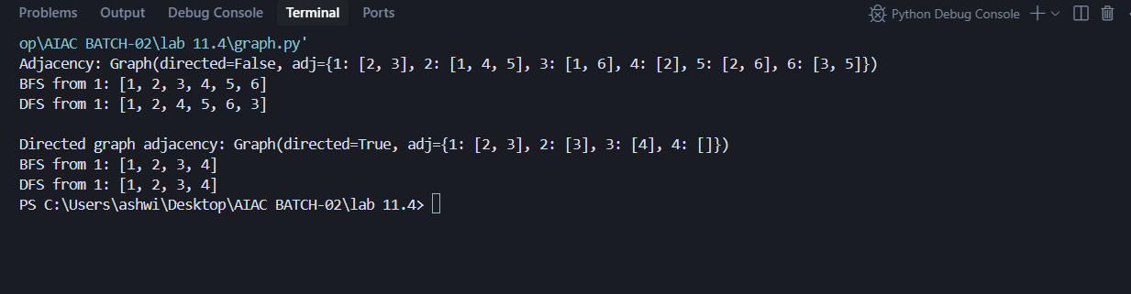 |  |  |  |  |  | Week6 - Thursday

